done IAM User Management and Access Control

1. 💻 EC2 instances
2. 📏 IAM Policies
3. 👩‍👩‍👧‍👧 IAM Users and User Groups
4. 🔖 AWS Account Alias

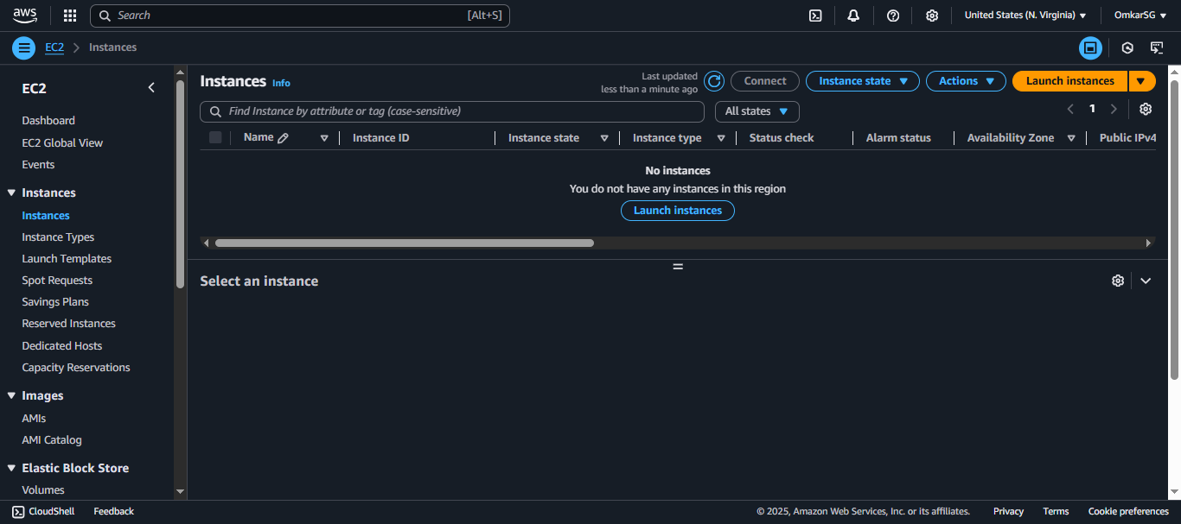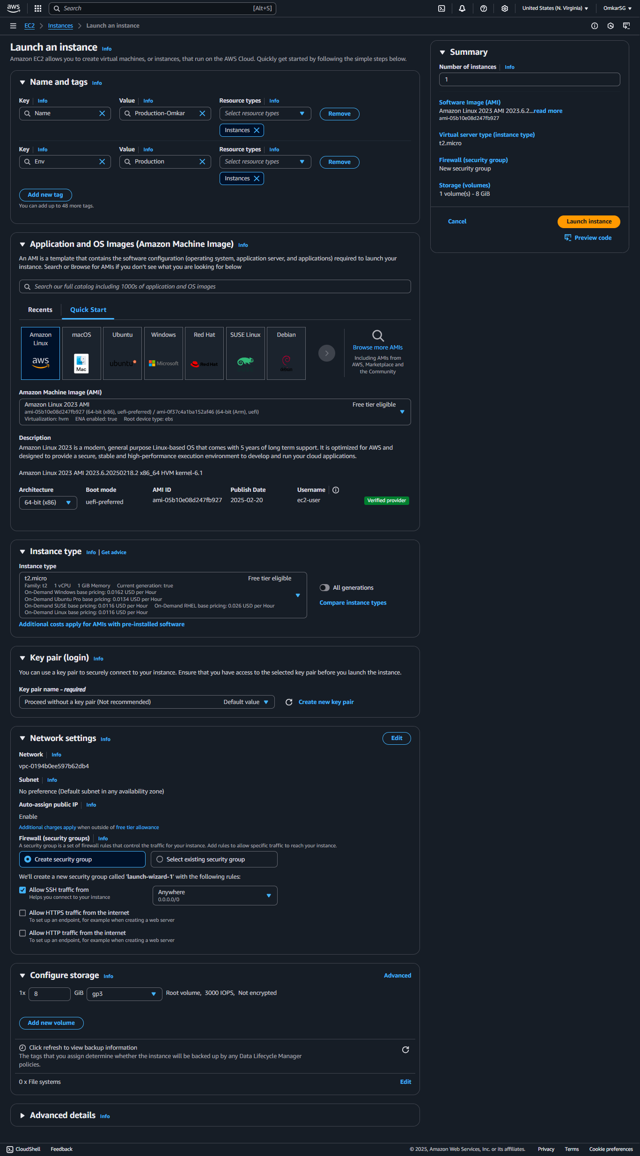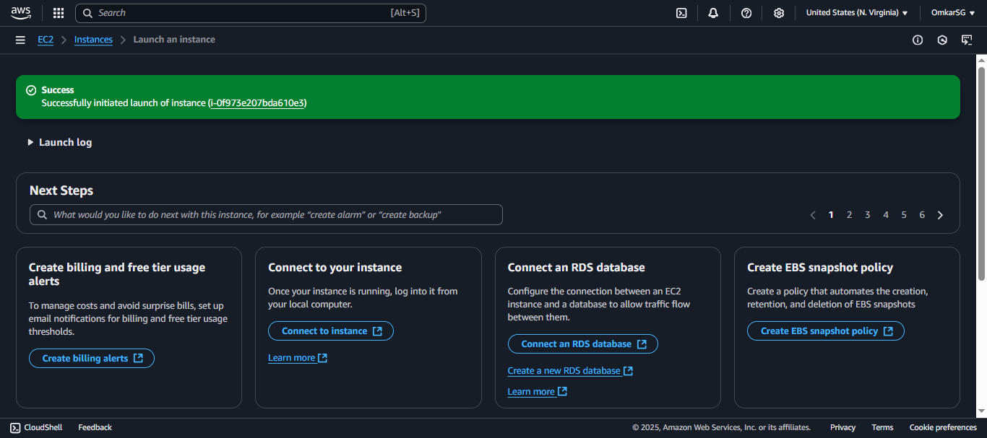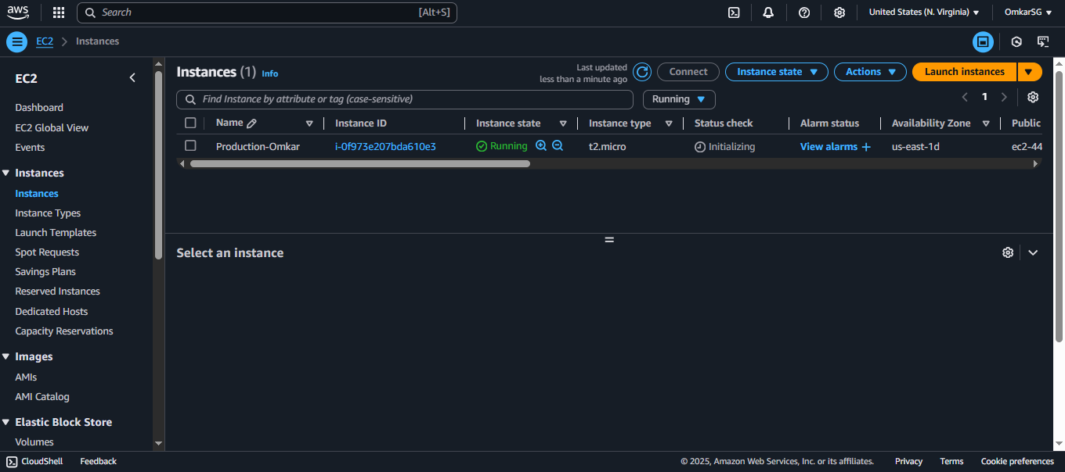now for Dev env

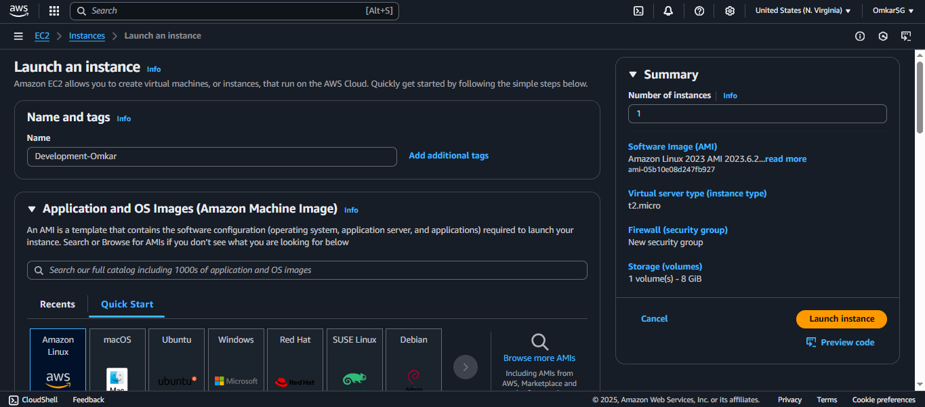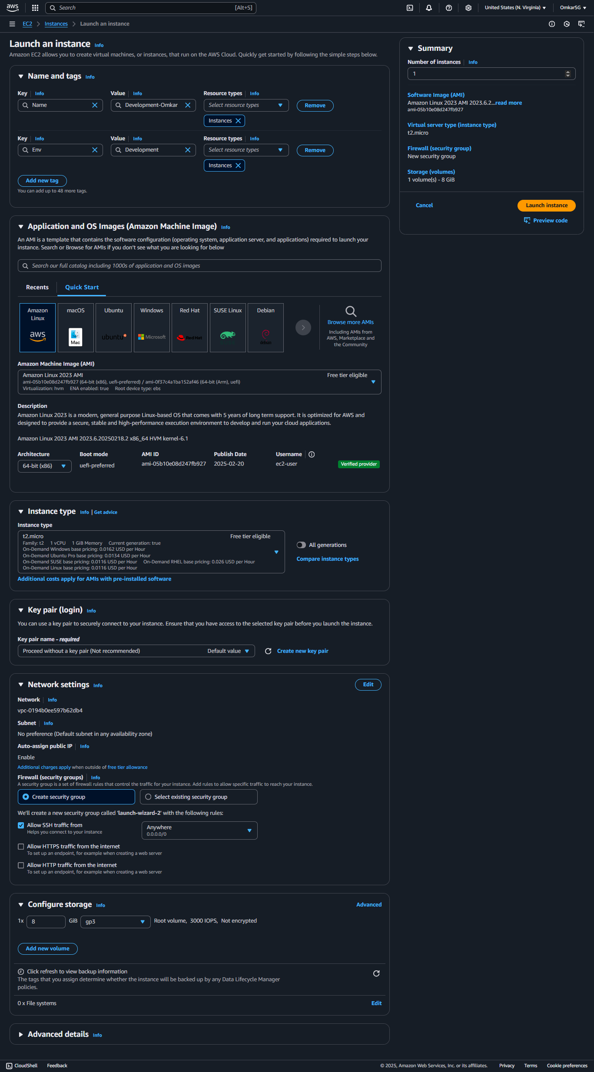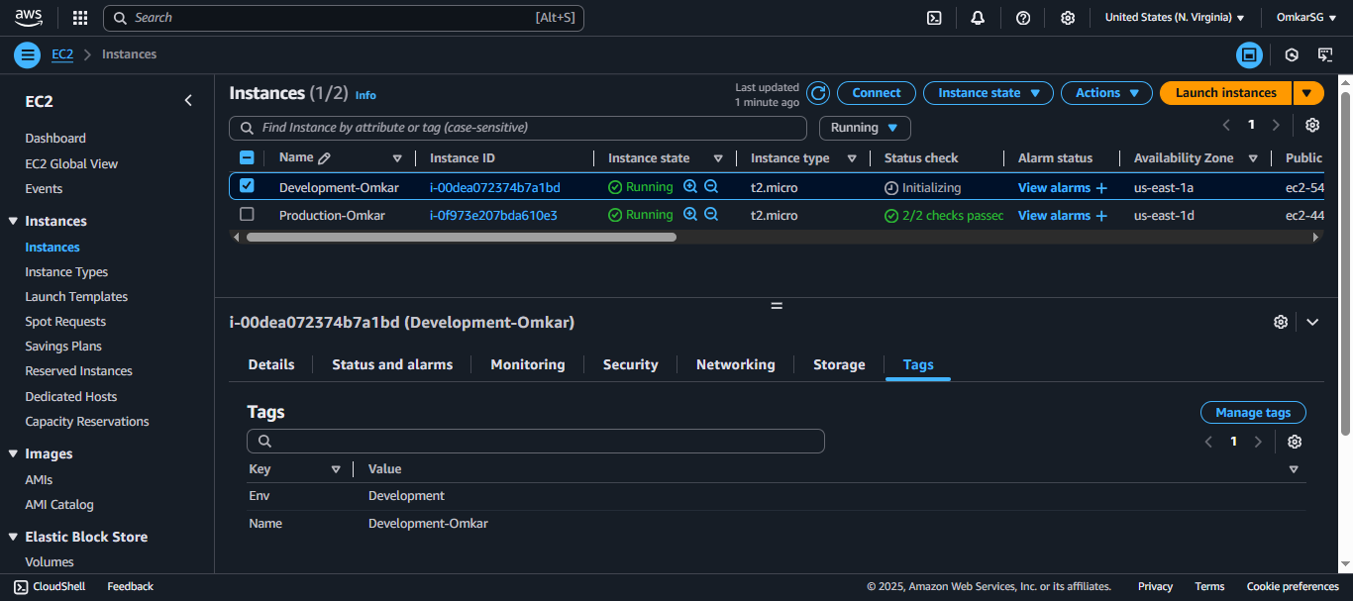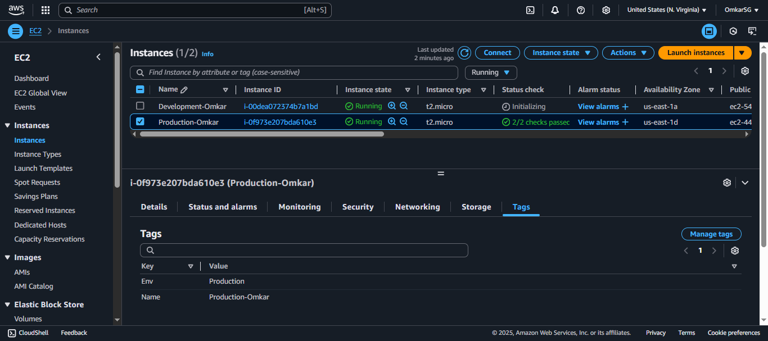created 2 instances one for Dev and other for Production and added tags as well

Now lets move towards creating IAM policy

Creat policy-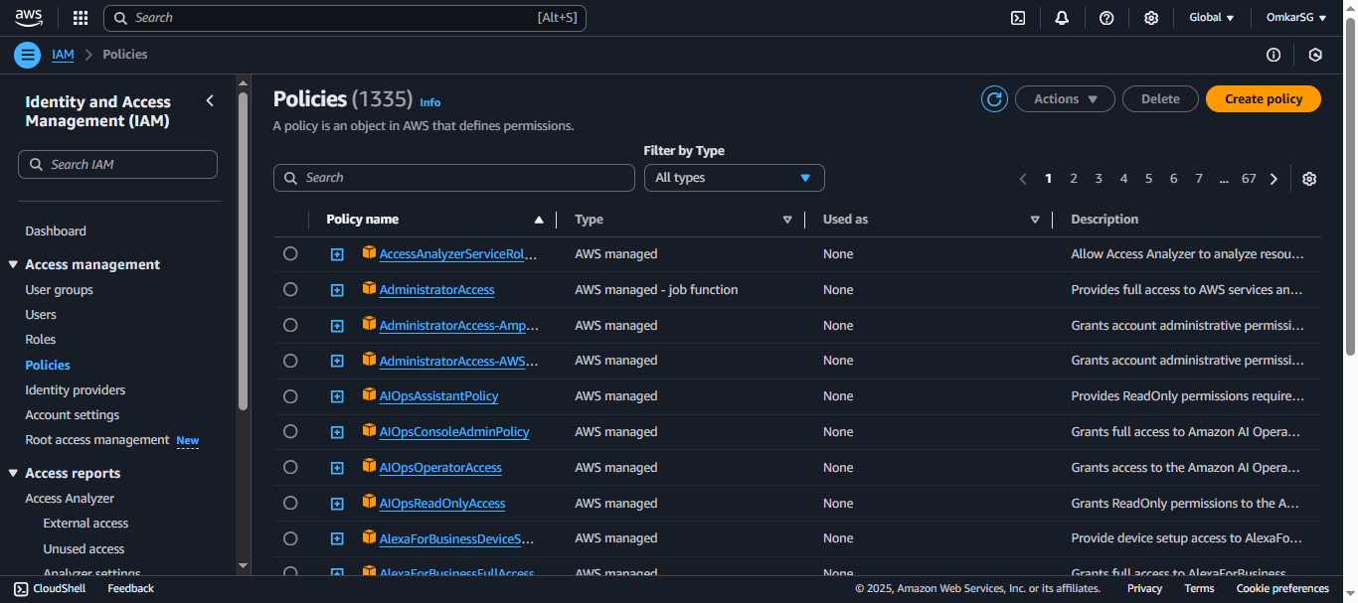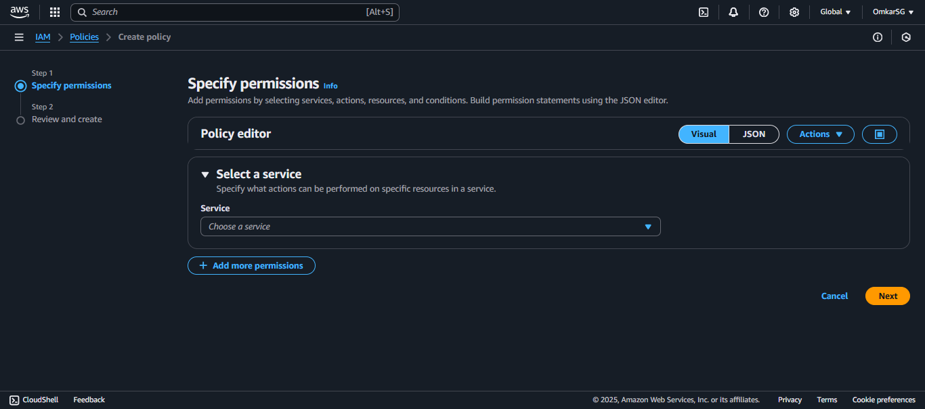

**{**

**"Version": "2012-10-17",**

**"Statement": [**

**{**

**"Effect": "Allow",**

**"Action": "ec2:*",**

**"Resource": "*",**

**"Condition": {**

**"StringEquals": {**

**"ec2:ResourceTag/Env": "development"**

**}**

**}**

**},**

**{**

**"Effect": "Allow",**

**"Action": "ec2:Describe*",**

**"Resource": "*"**

**},**

**{**

**"Effect": "Deny",**

**"Action": [**

**"ec2:DeleteTags",**

**"ec2:CreateTags"**

**],**

**"Resource": "*"**

**} ]**  **}**

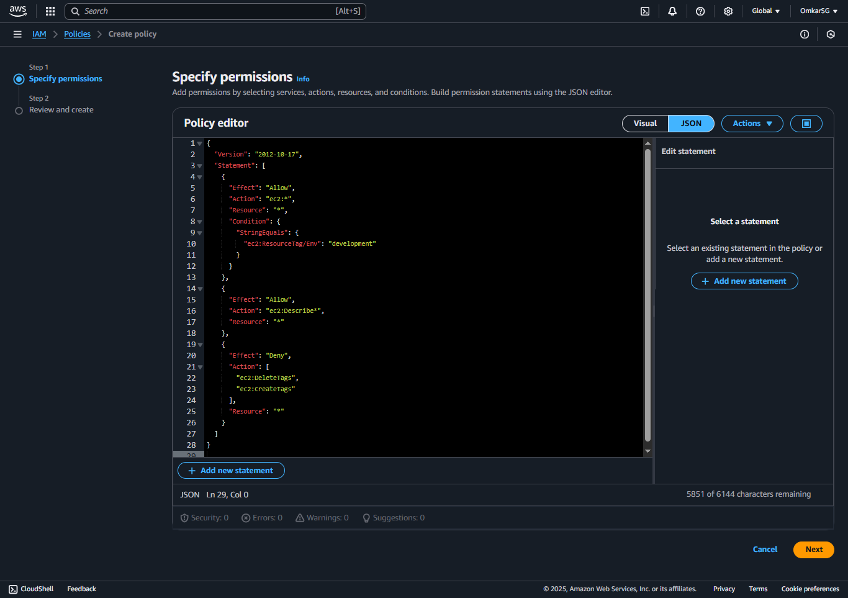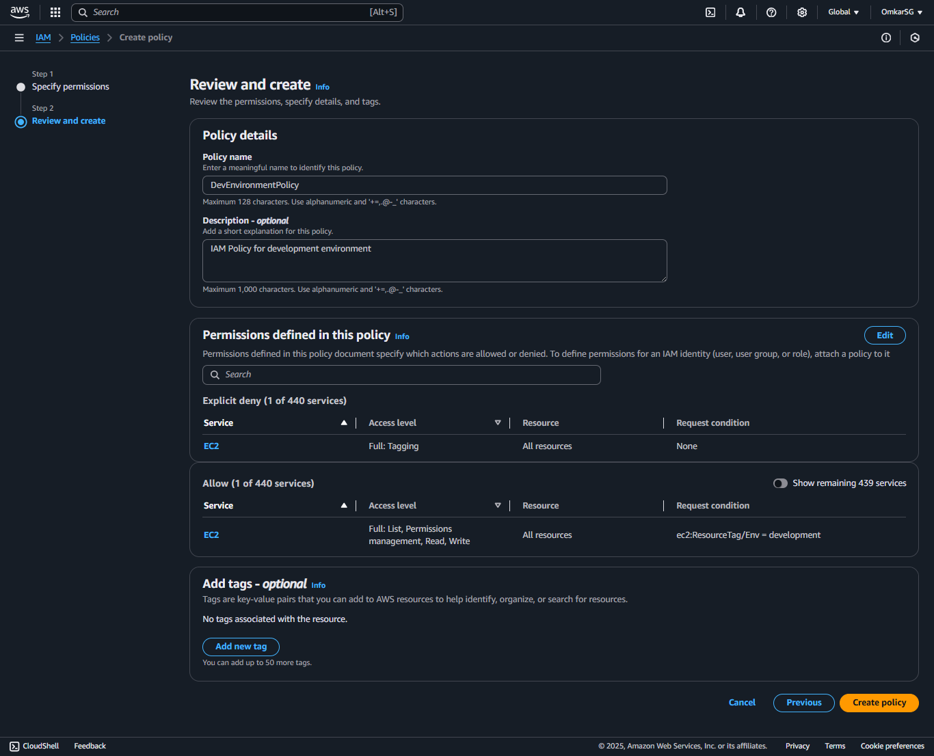**DevEnvironmentPolicy DevEnvironmentPolicy**

As we have created the policy now we’ll move towards creating AWS Account Alias

**Create an AWS Account Alias**

* Head to your IAM dashboard.
* In the right-hand side of the dashboard, choose **Create** under **Account Alias**
* In the **Preferred alias** field, enter **alias-Omkar**.

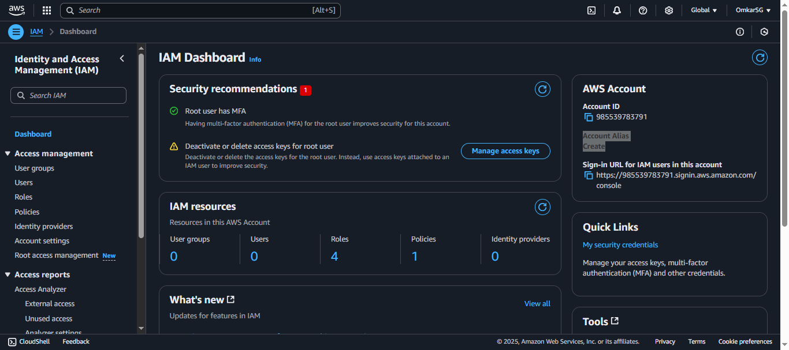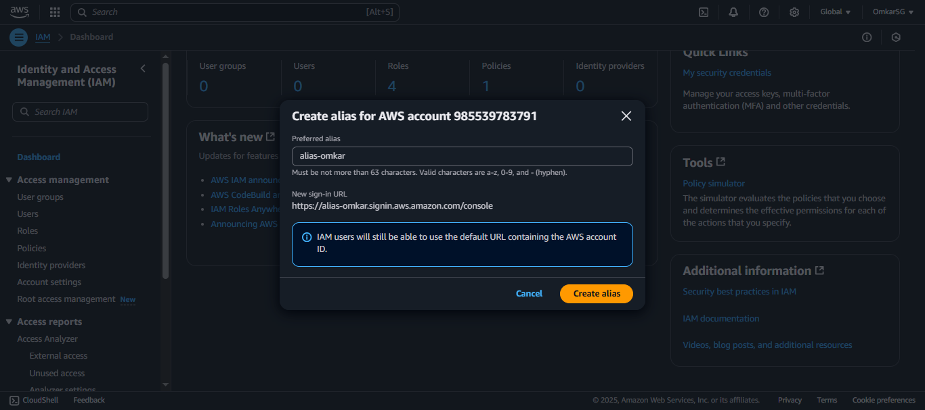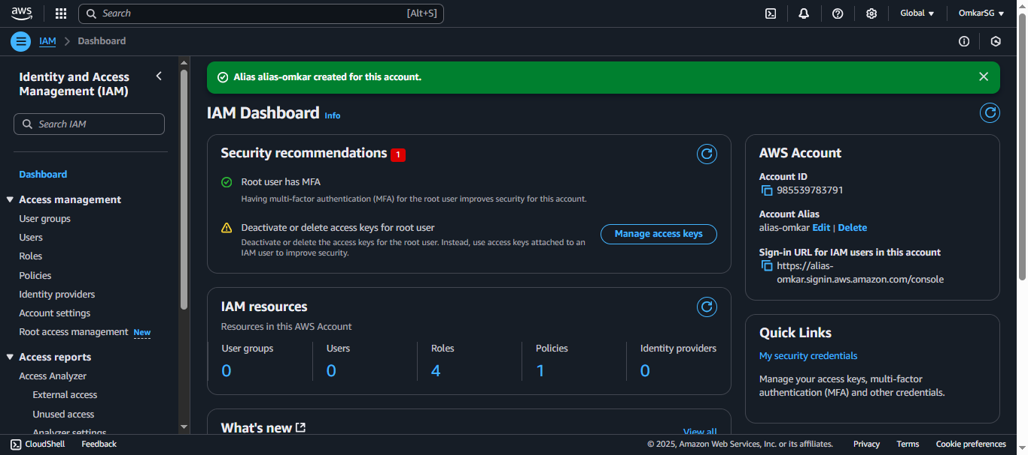as we created alias successfully now we’ll move to Creating IAM Users and User Groups

Lets create usergroup first with attching policy we created for devlopers - **DevEnvironmentPolicy**

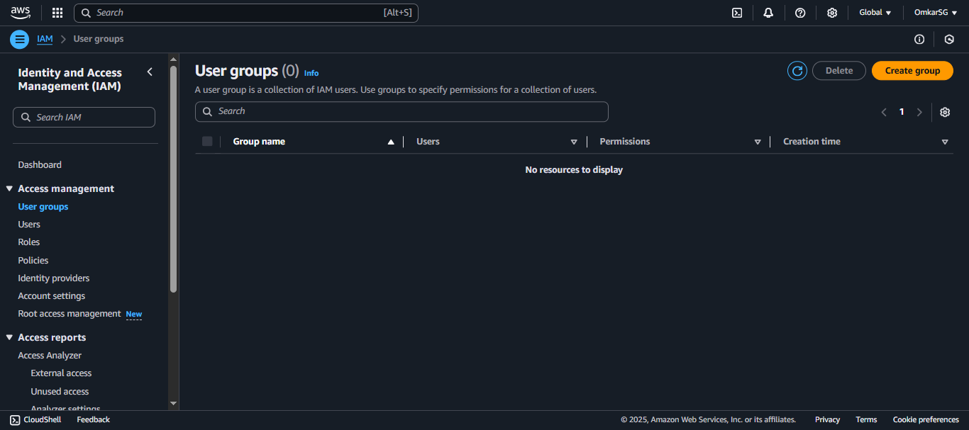 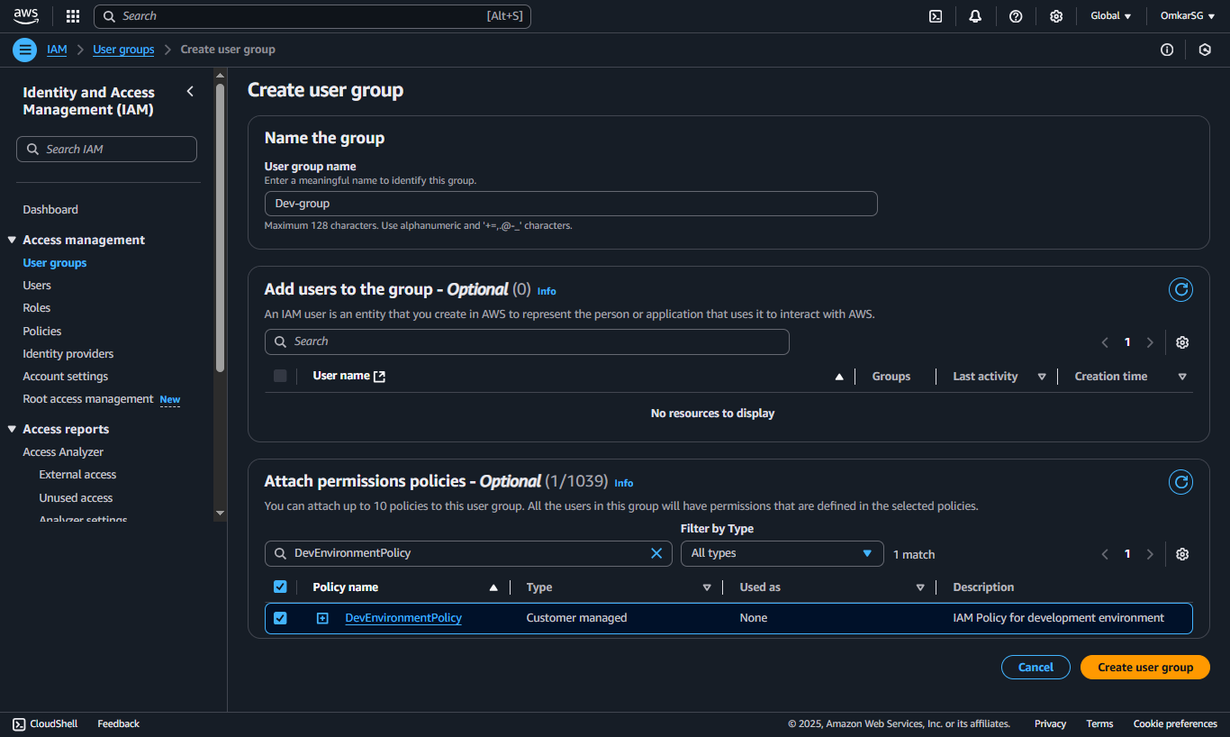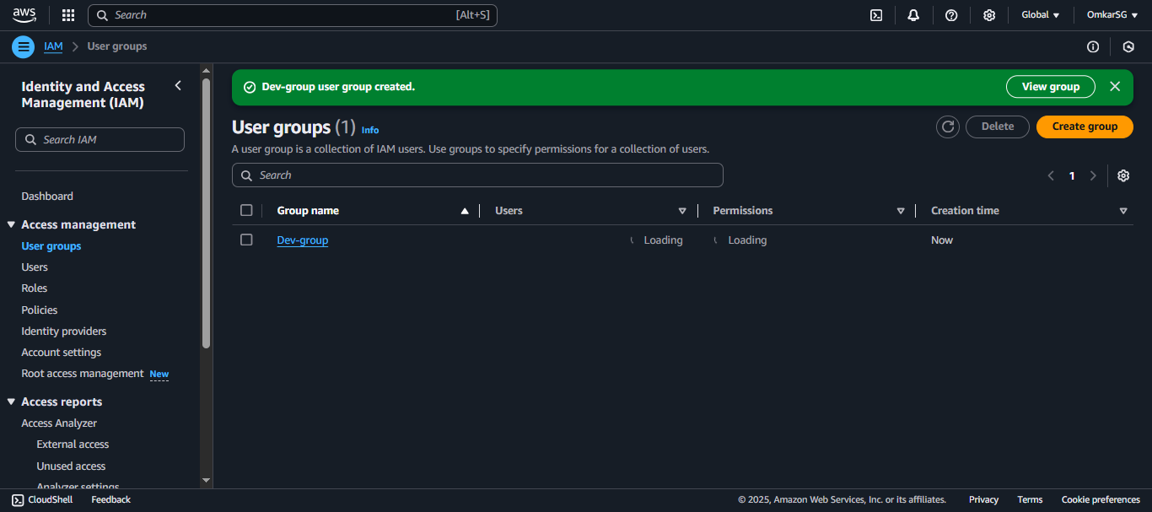

now lets create users

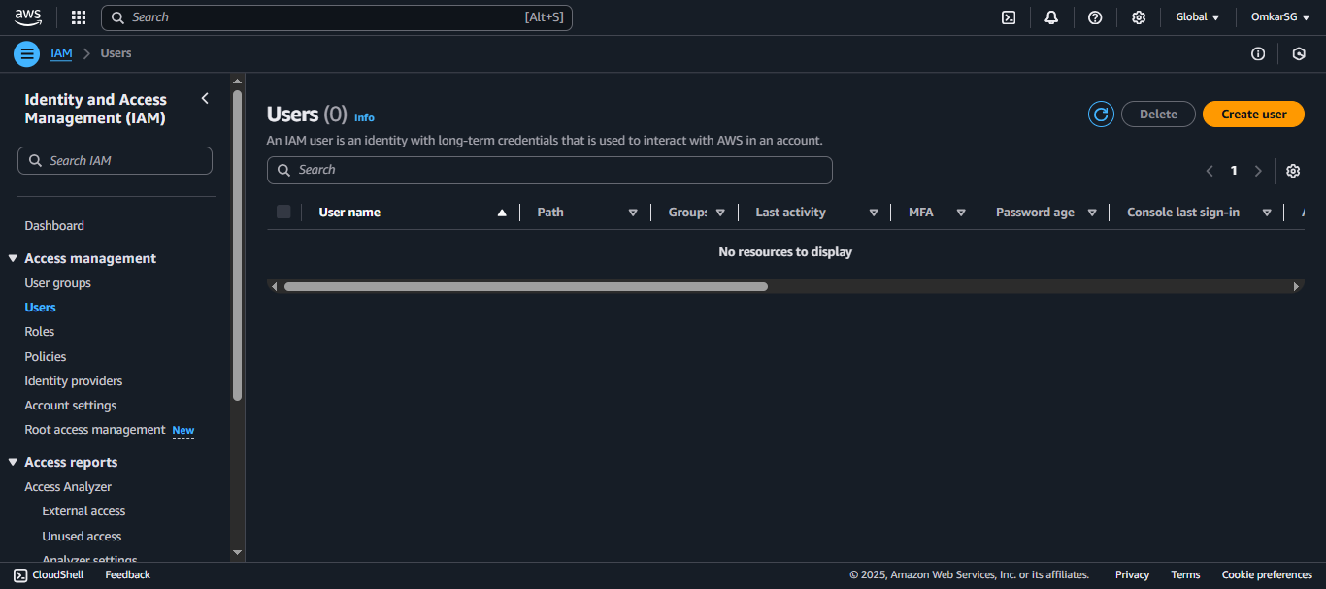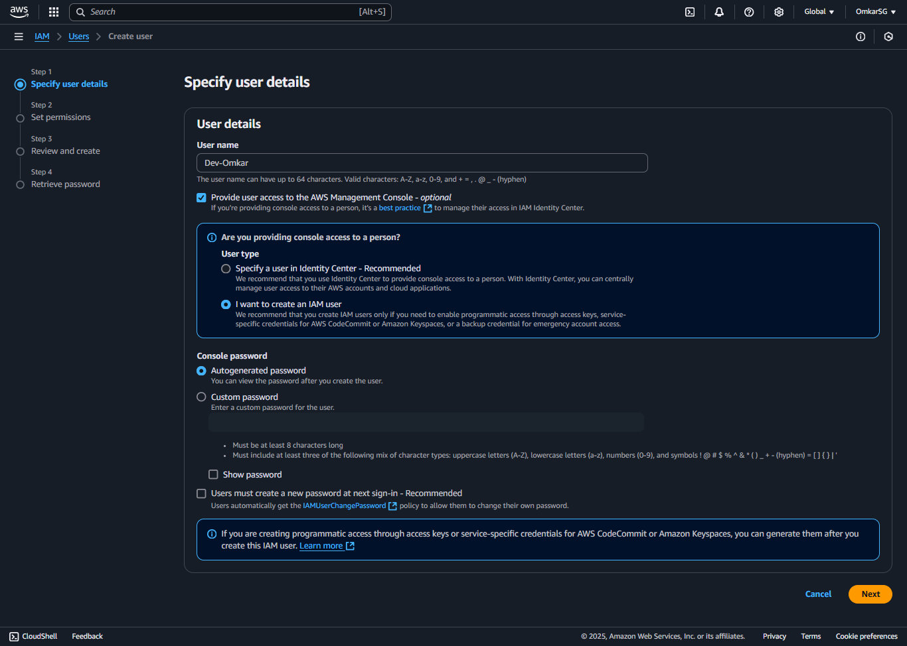adding group to the user 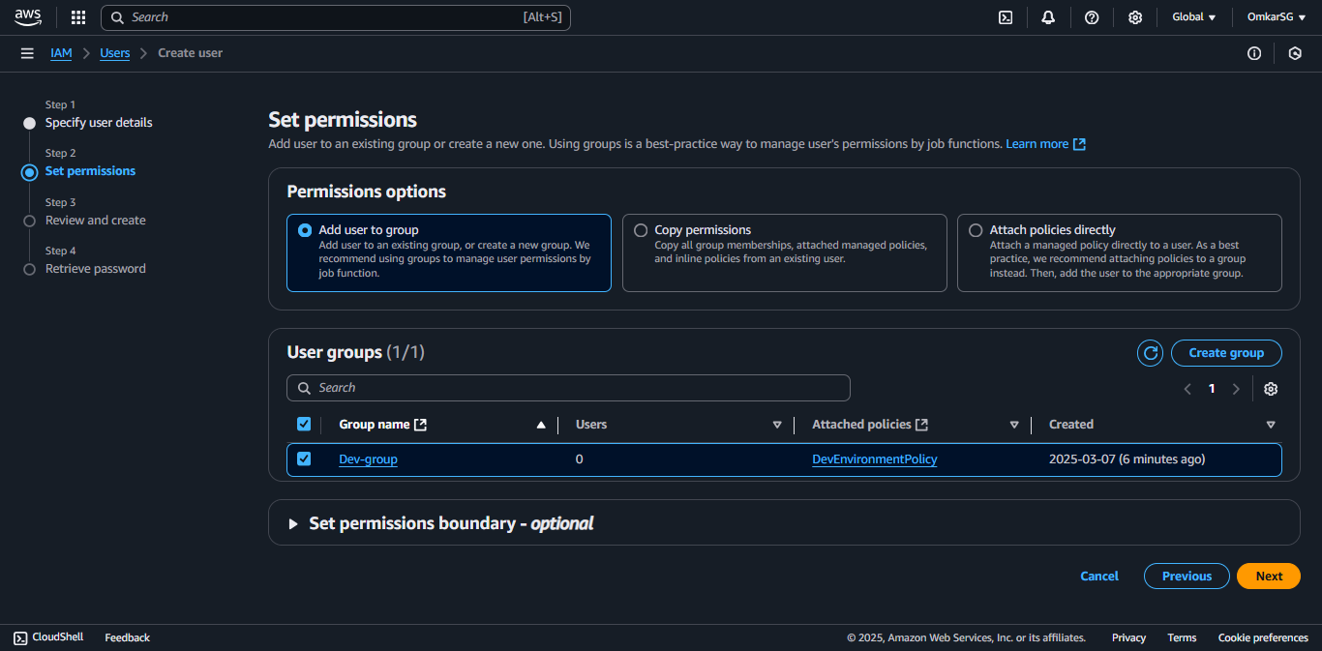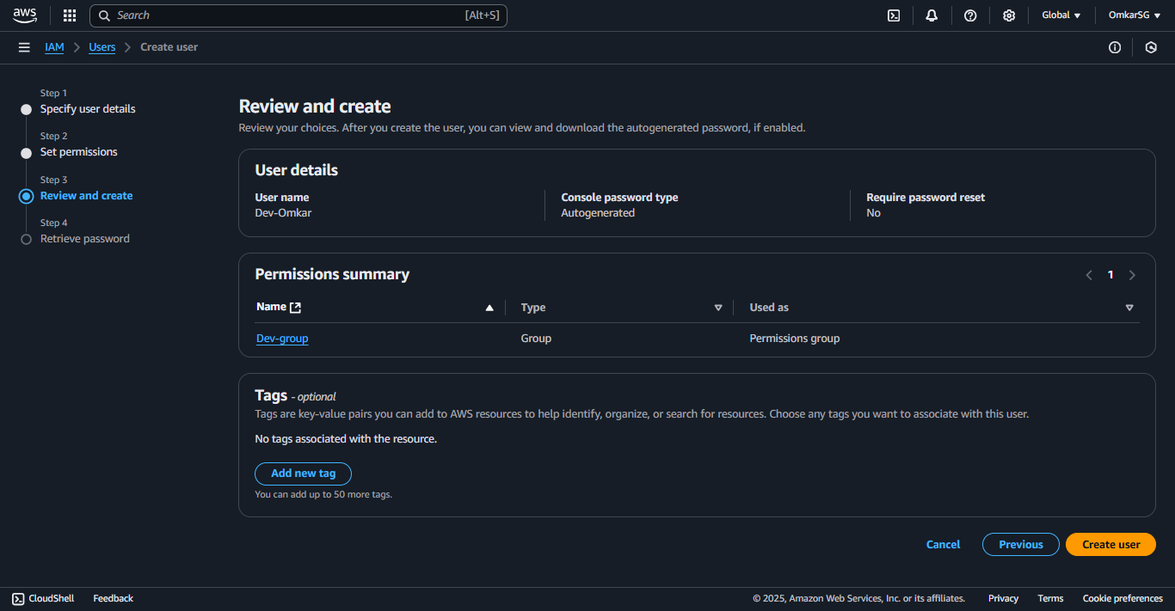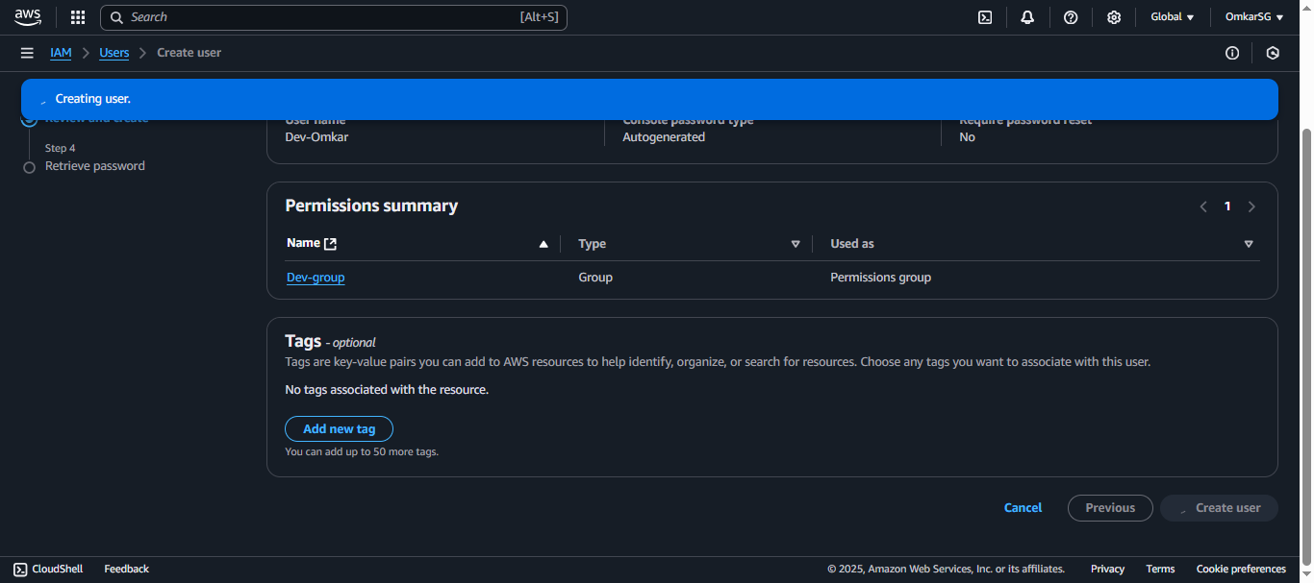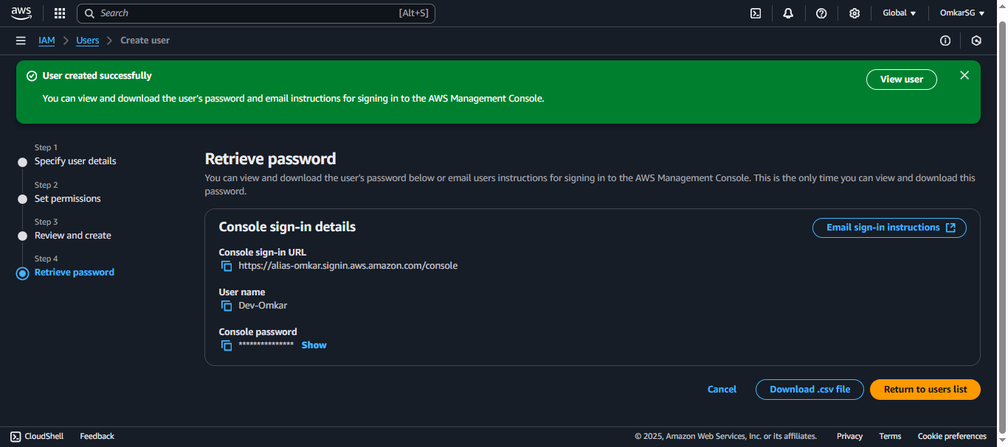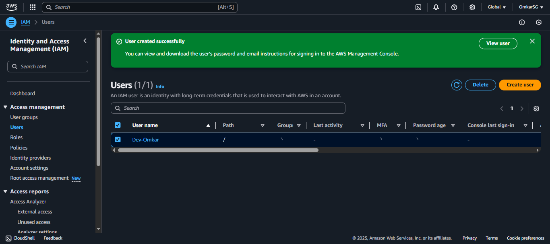now as we have created user and created usergroup with policies now we’ll just test our dev user by logging in with creadentials provided

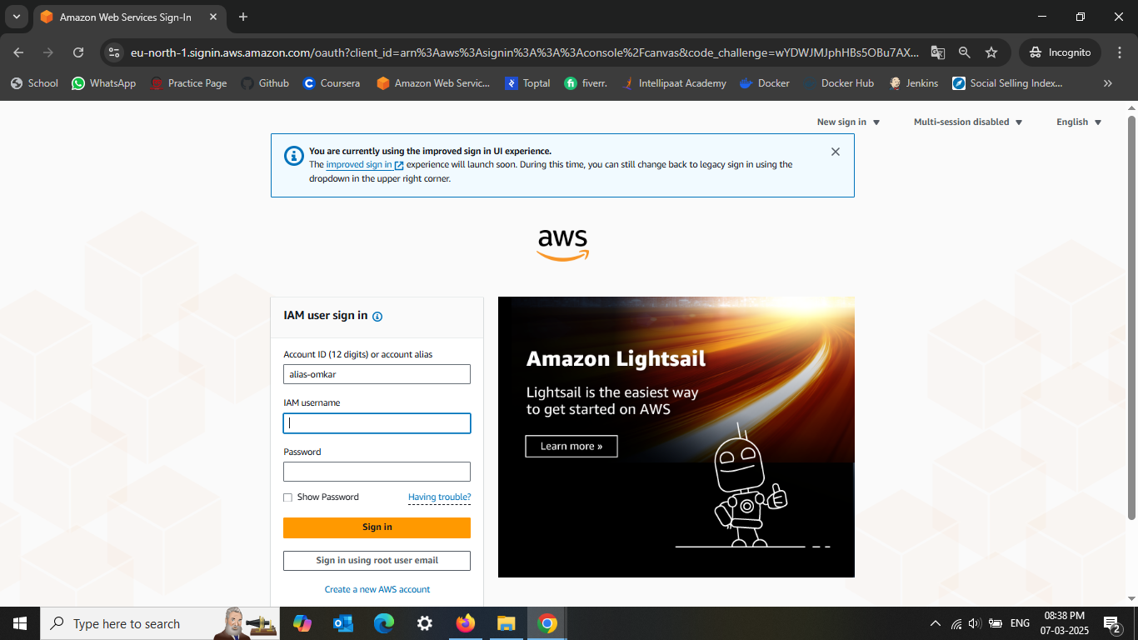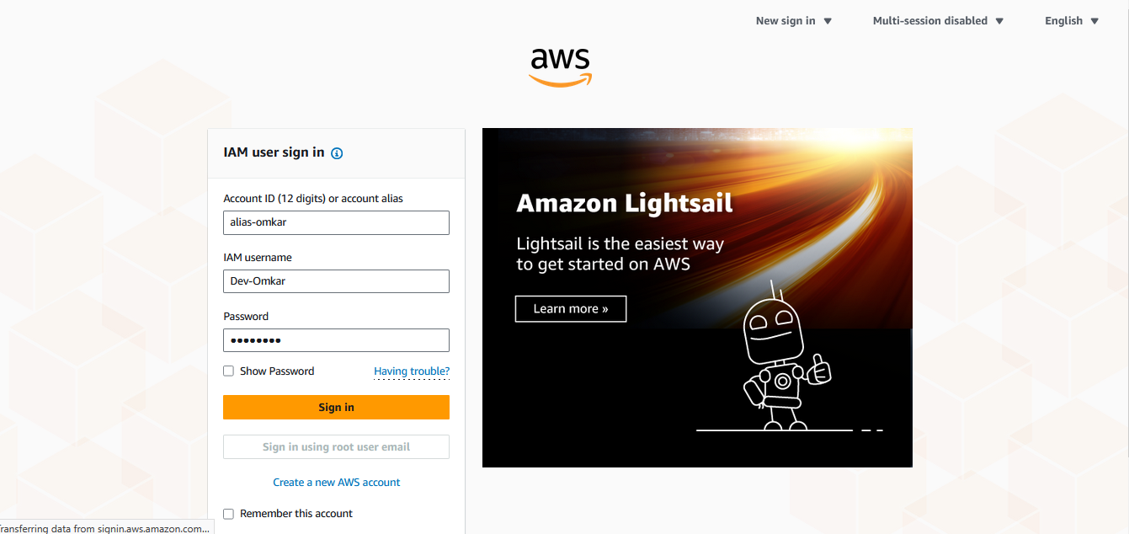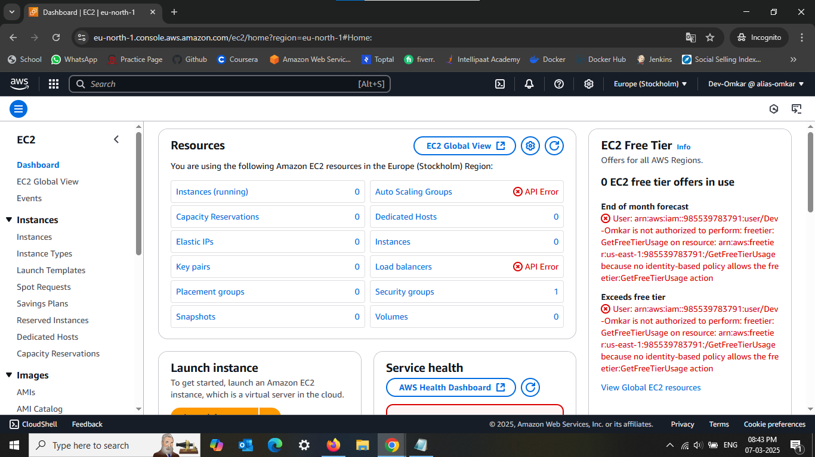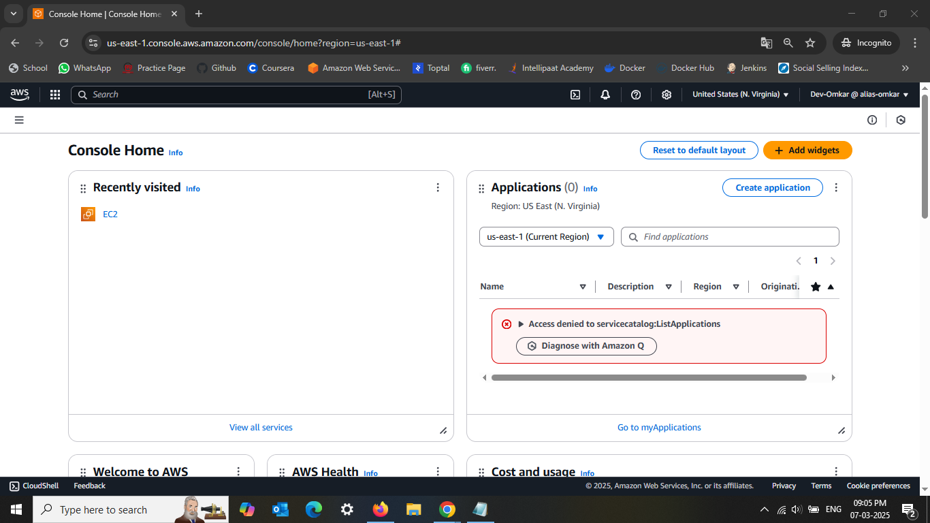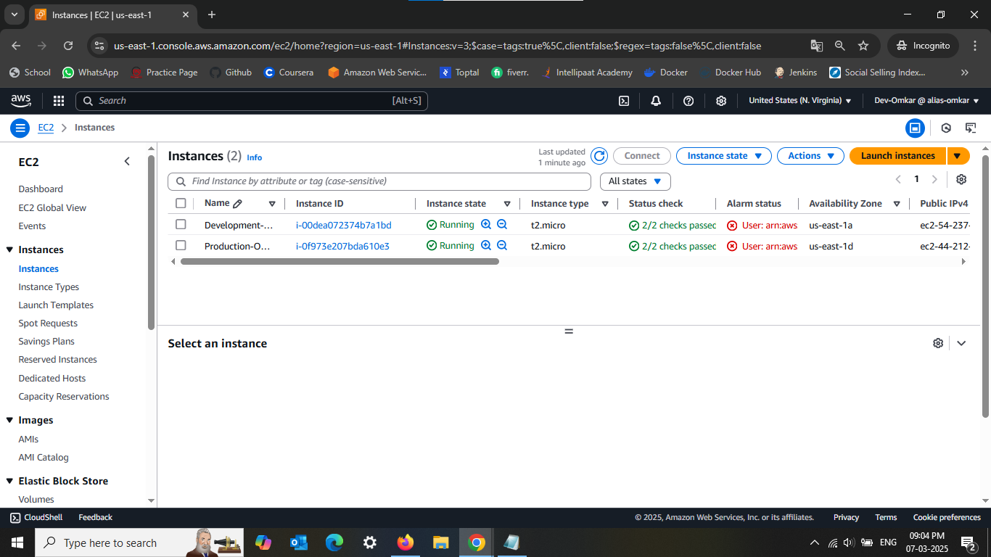

Now i will try to **STOP** the **Production-Omkar** env first

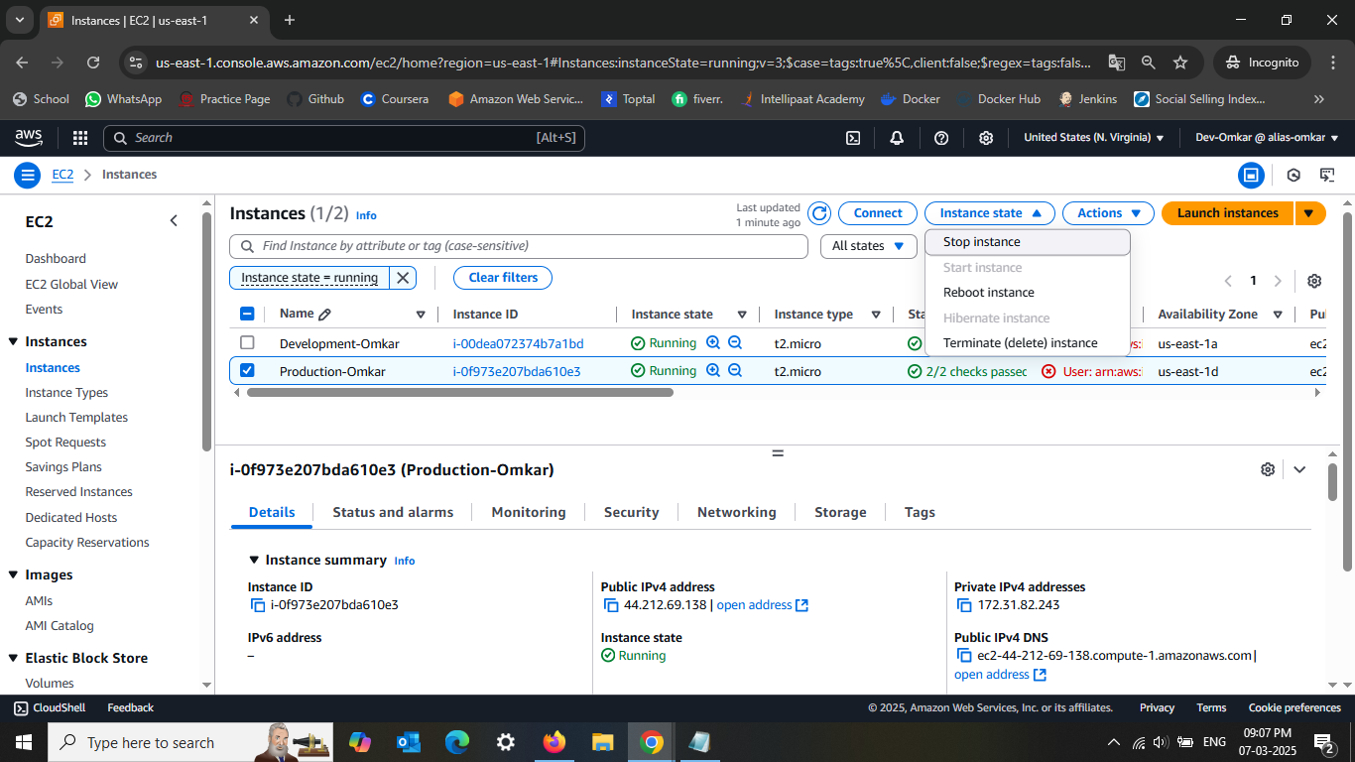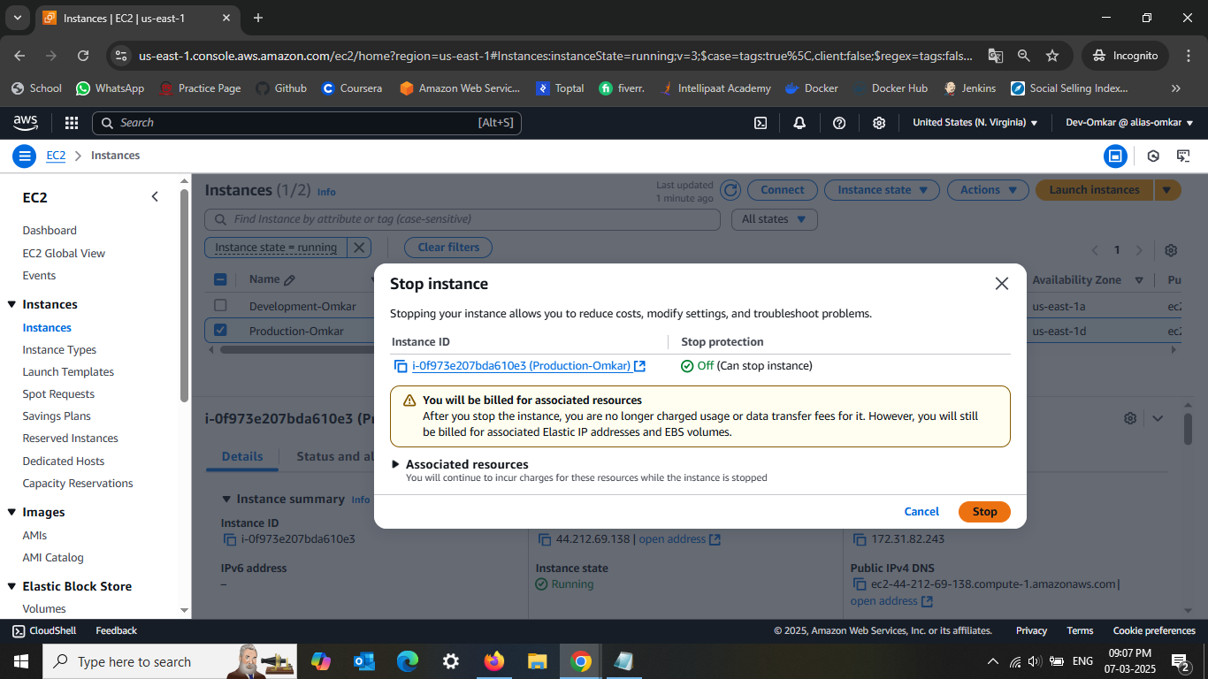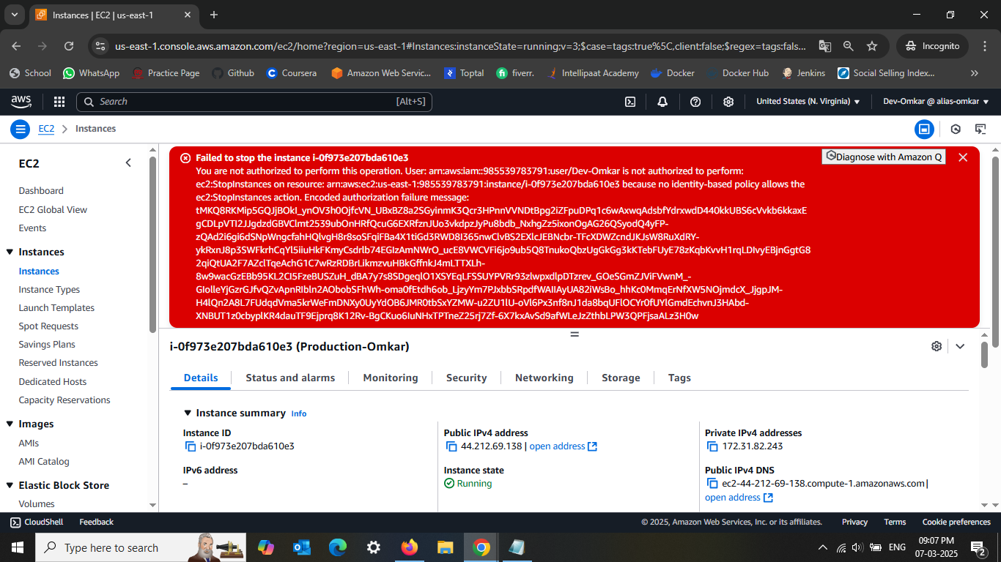As Expected i am not able to stop it coz of IAM policy is not allowing to do so with Dev AC

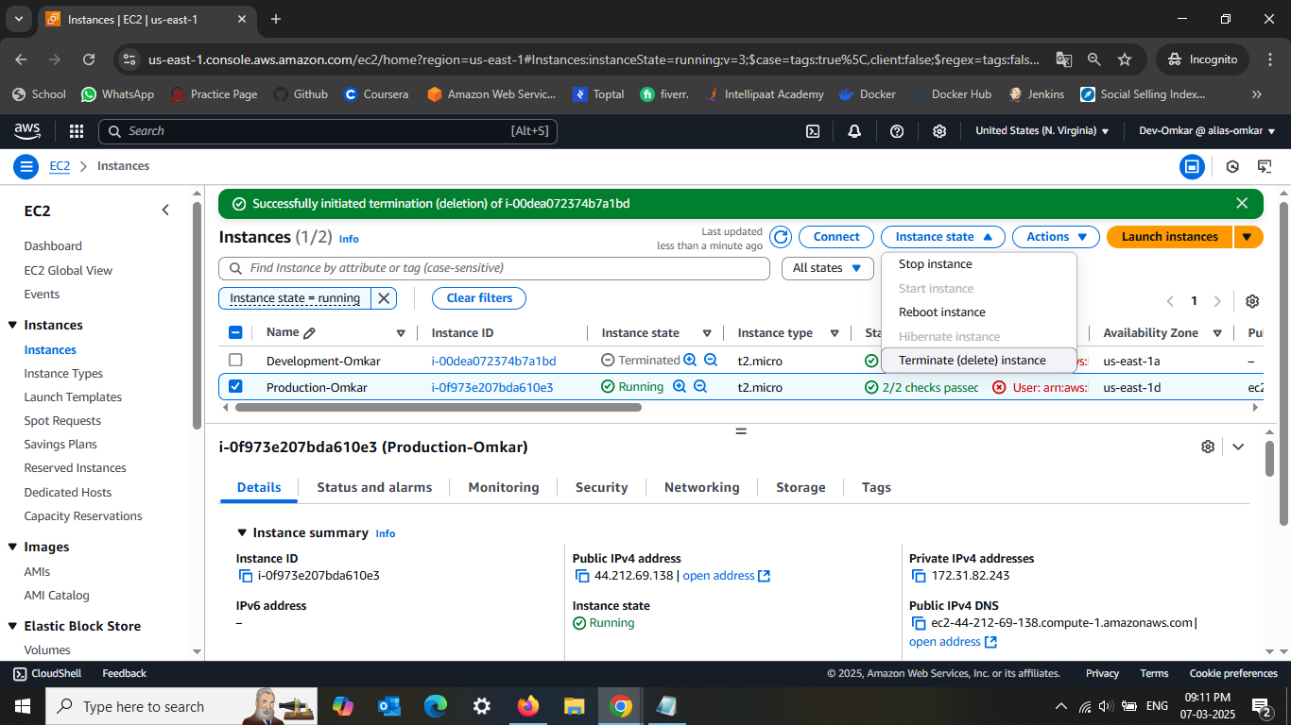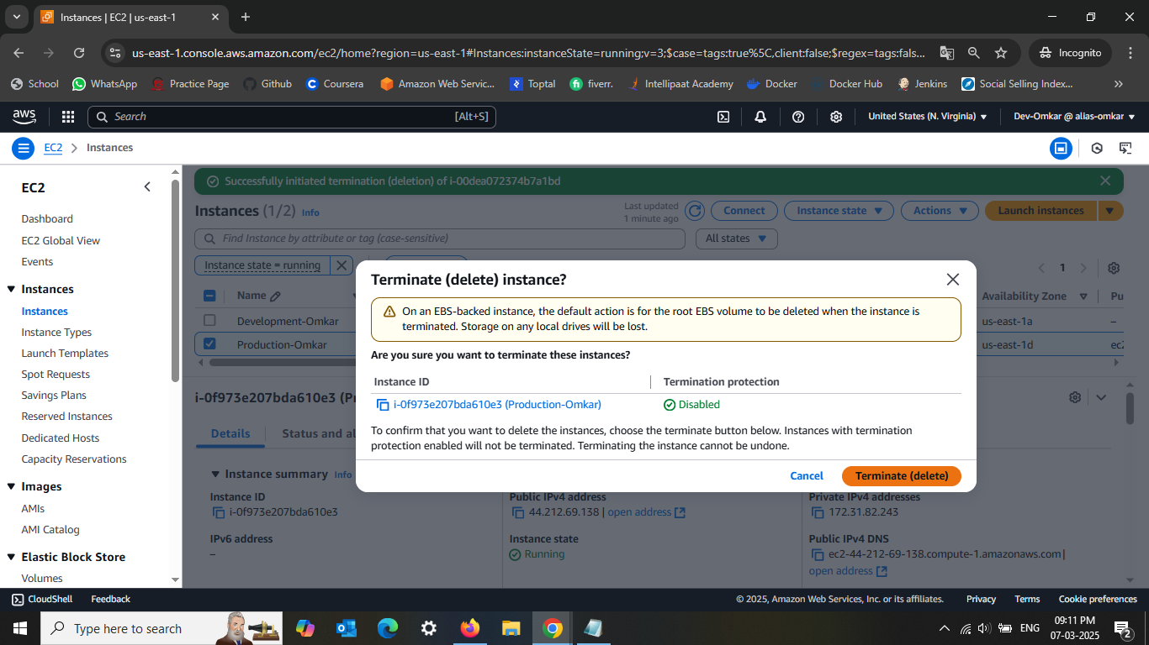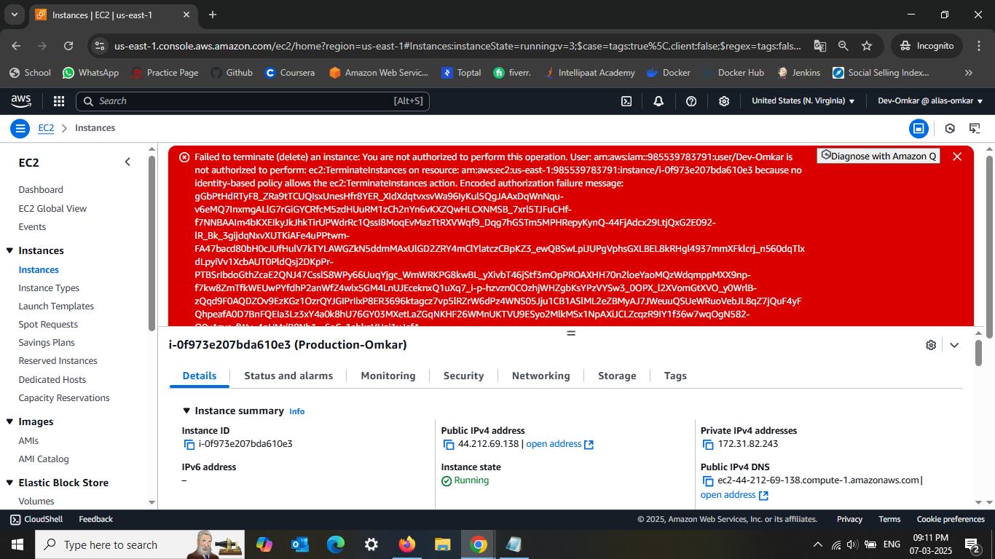

Lets try to **STOP** the **Development-Omkar** env

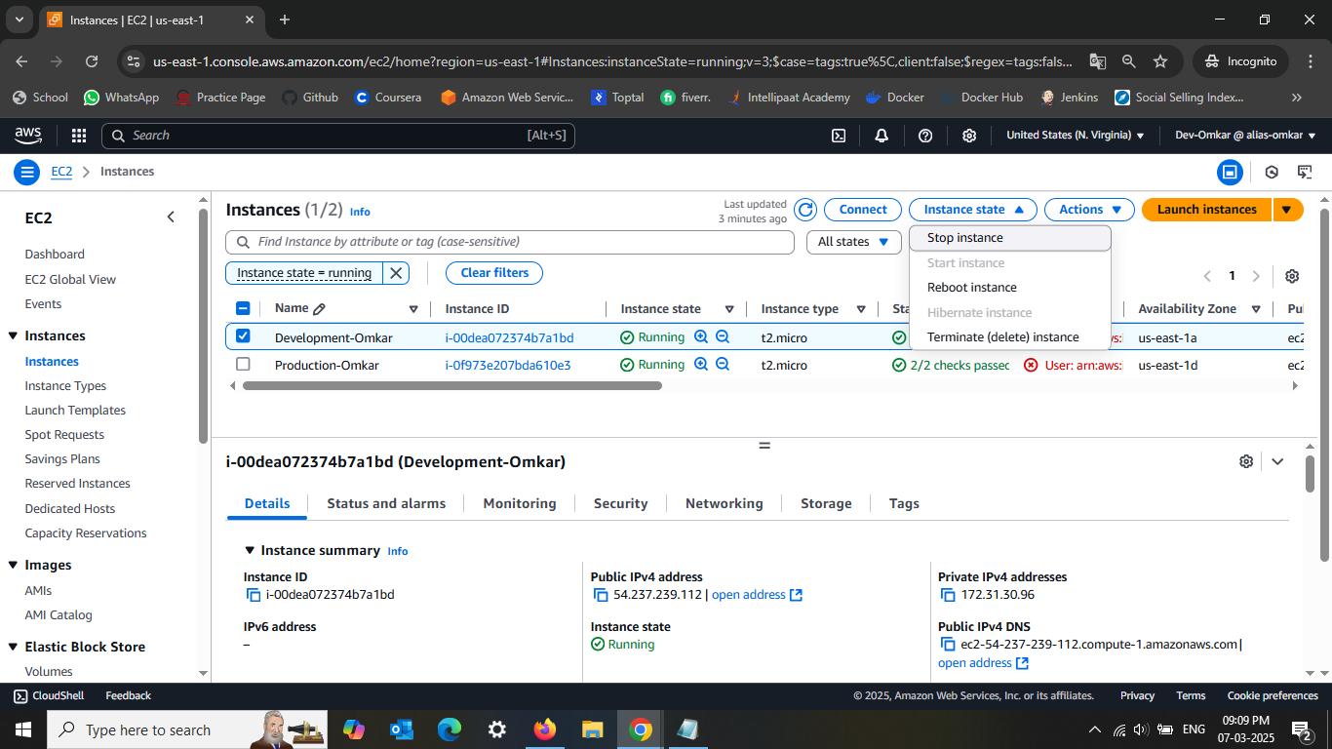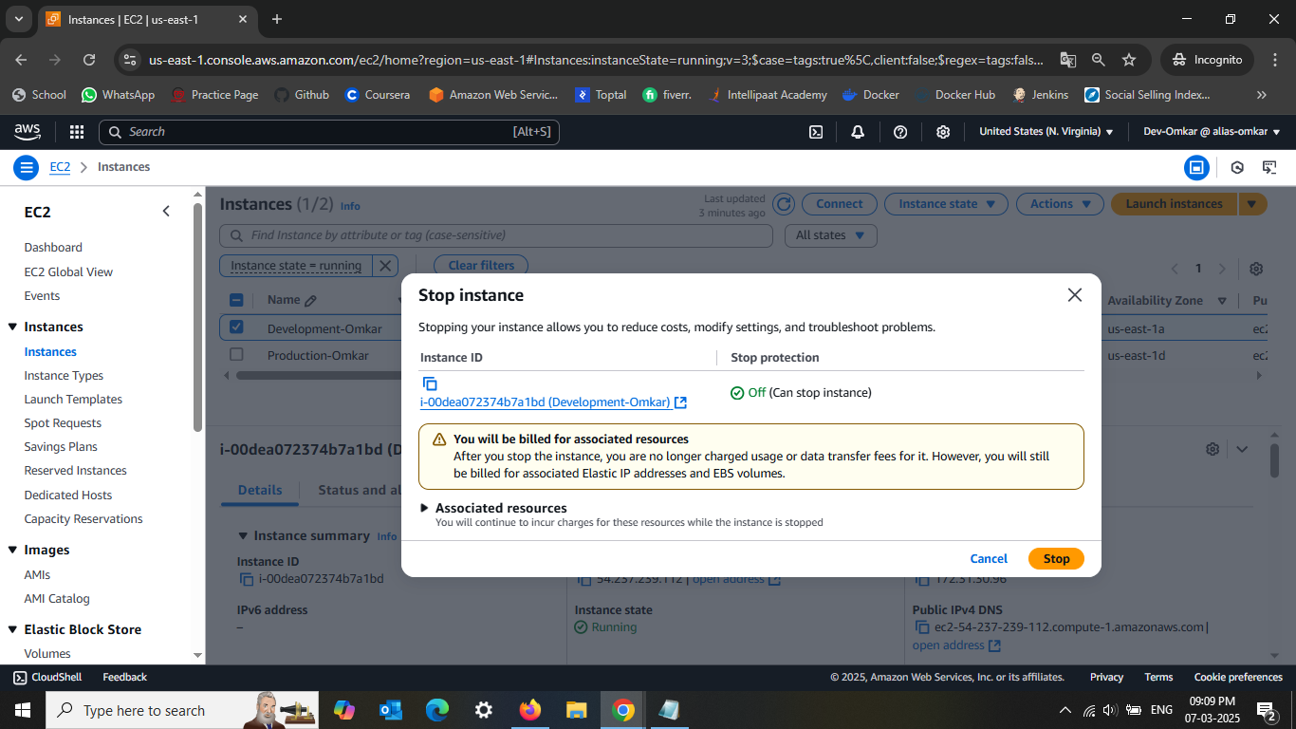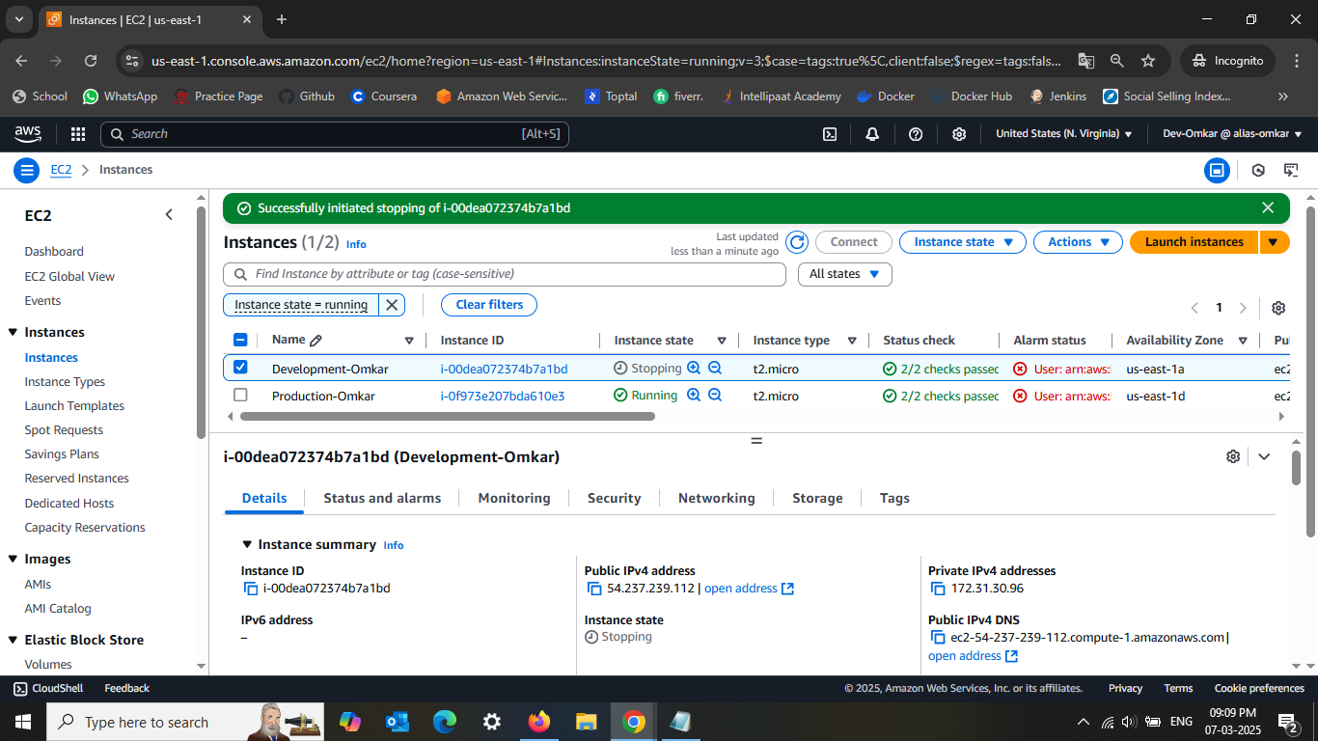As you can see i can **STOP** it....

And also i can terminate as well 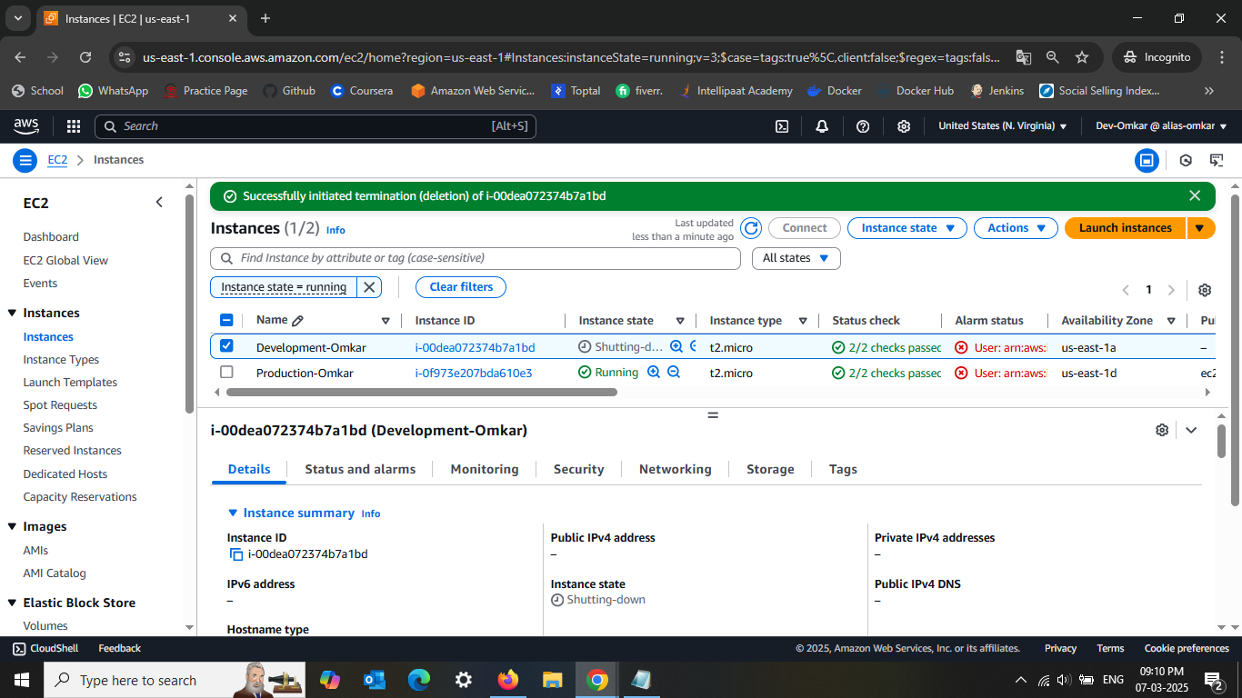

And i can see the same from Root User AC as well  
